Terraform task 1
1). Install Terraform on your PC
2). Execute all the templates shown in video.
3). Note down below points, Terraform Init Terraform Plan Terraform Apply Terraform Provider.
4). Integrate a sample Terraform template in Jenkins.

1). Install Terraform on your PC.

Step 1: Download Terraform
Open the official HashiCorp Terraform download page:
Terraform Downloads — HashiCorp
Under Windows, download:
AMD64 → ZIP
If your Windows PC is a normal Intel/AMD 64-bit machine, choose AMD64.

Step 2: Create a Terraform folder
Open File Explorer and create:
C:\Terraform
So you will have:
C:\
└── Terraform\

Step 3: Extract Terraform
The downloaded file will look similar to:
terraform_1.x.x_windows_amd64.zip
Open the ZIP file.
Inside you should see:
terraform.exe
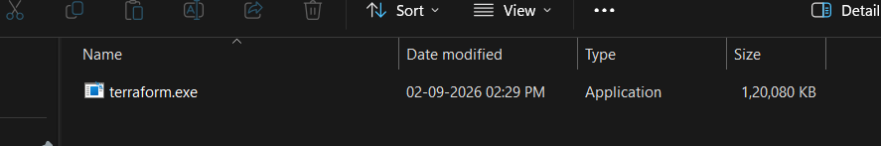
Extract terraform.exe into:
C:\Terraform
Your folder should now look like:
C:\Terraform\terraform.exe

Step 4: Add Terraform to PATH
Press:
Windows key
Search for:
Environment Variables
Select:
Edit the system environment variables
Then:
Advanced → Environment Variables
Under System variables, find:
Path
Select it → Edit → New
Add:
C:\Terraform
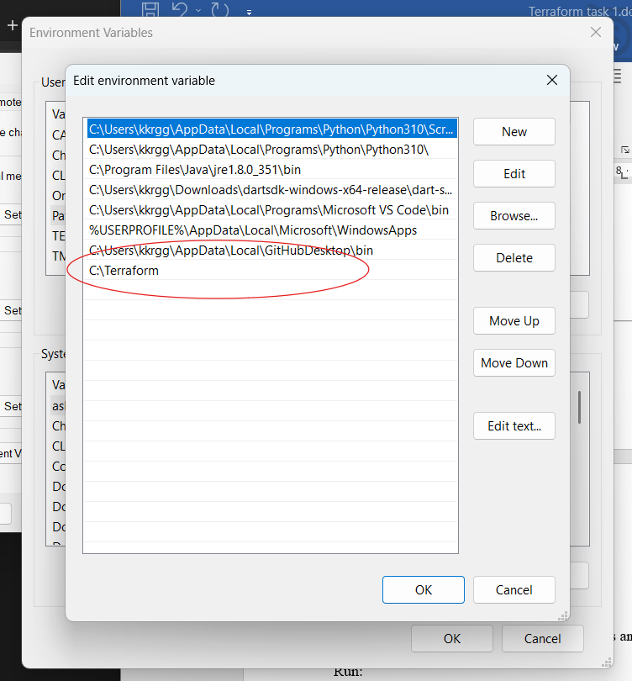
Click:
OK → OK → OK

Step 5: Open a NEW terminal
This is important.
Close any existing PowerShell/CMD windows and open a new PowerShell.
Run:
terraform -version
You should get:
Terraform v1.x.x
on windows_amd64
Also check where Windows is finding Terraform:
where.exe terraform
Expected:
C:\Terraform\terraform.exe

Step 6: Test Terraform
Run:
Terraform
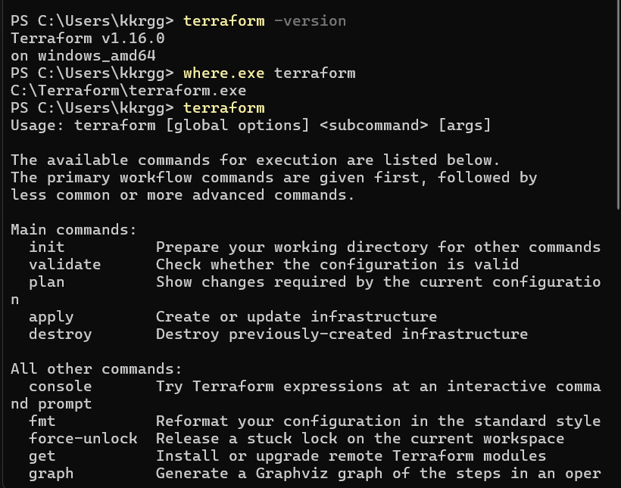

2). Execute all the templates shown in video.

Configuration of basic terraform resource with provider
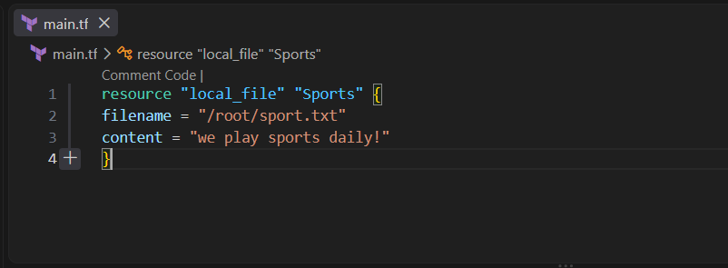

Terraform init
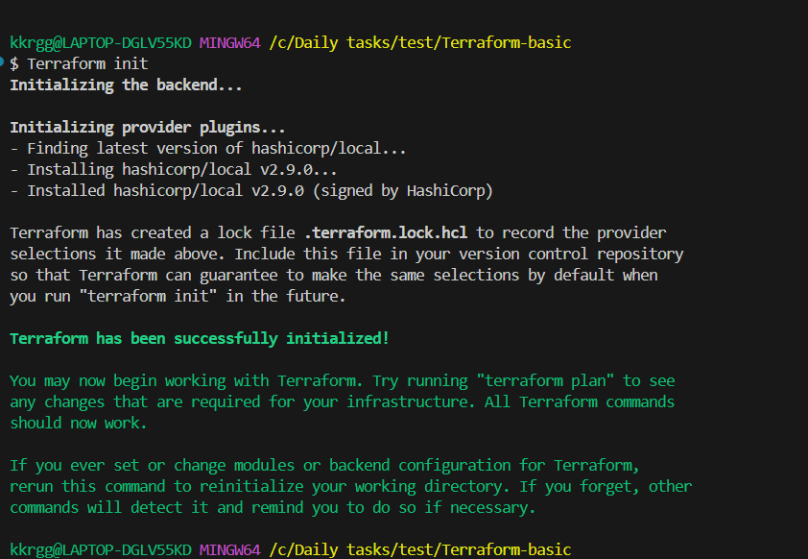

Terraform plan
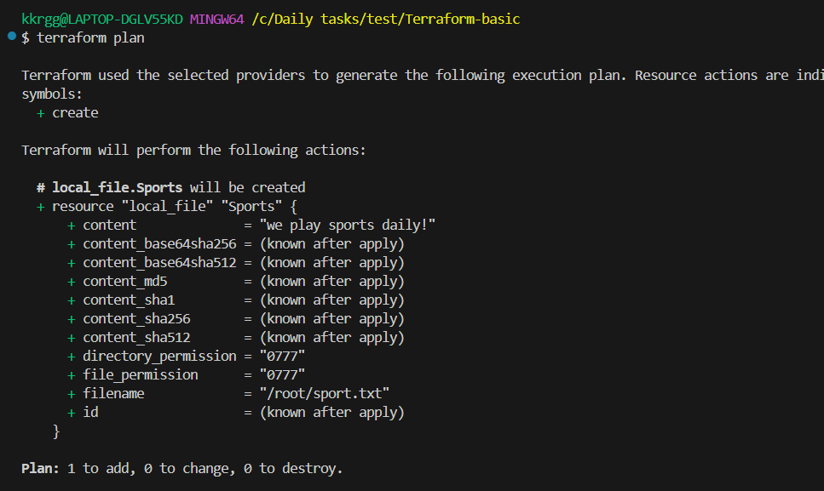
Terraform apply
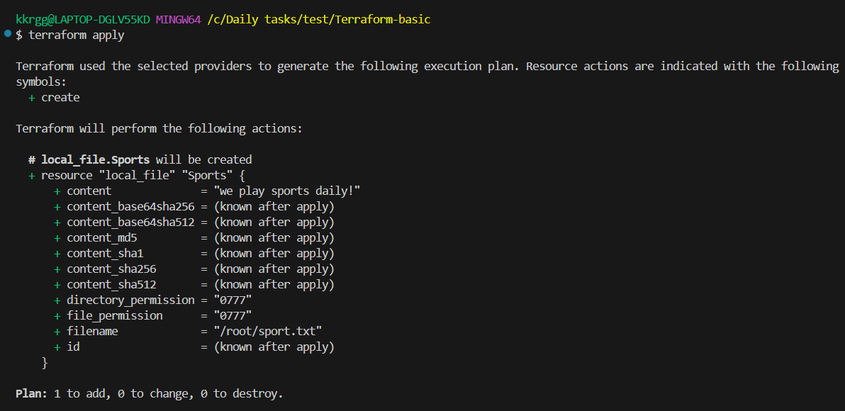
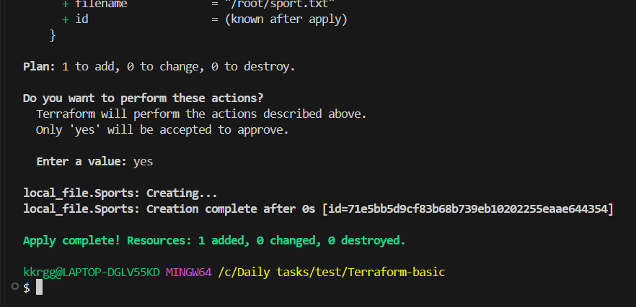

A folder called sports created successfully.
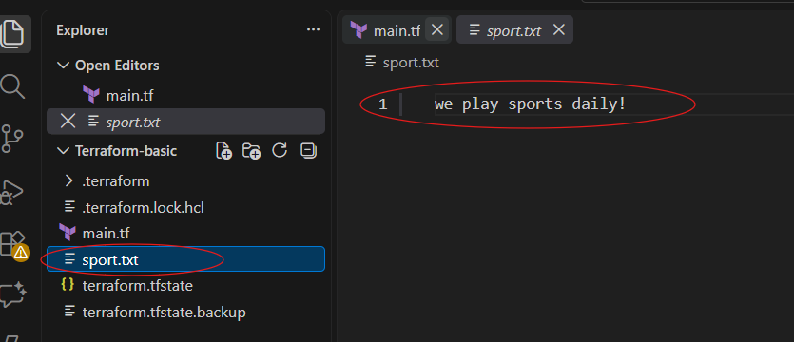

Multiple providers:
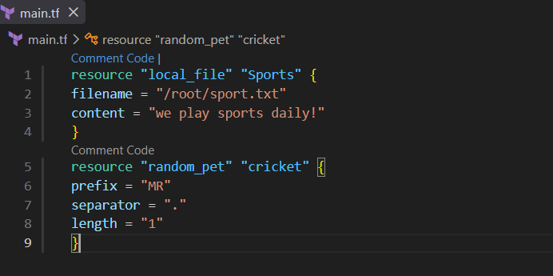

Terraform init
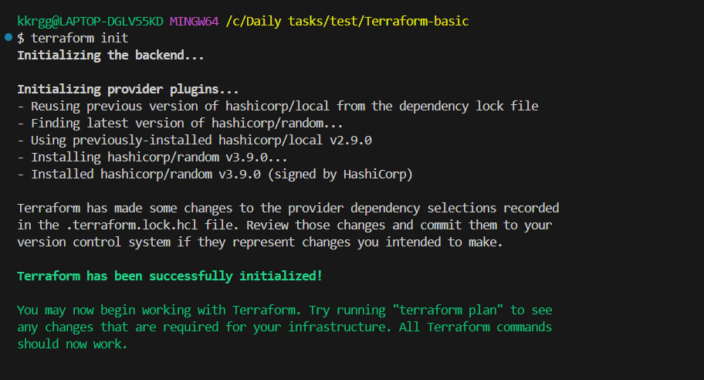

Terraform plan
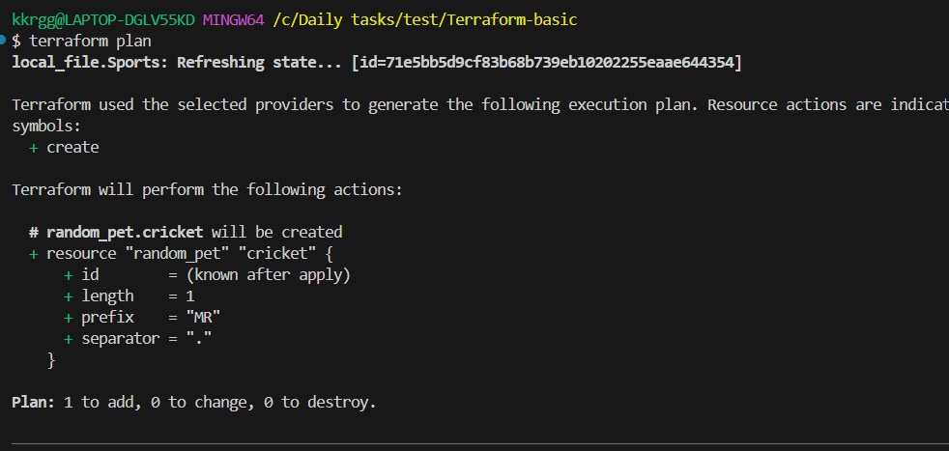

Terraform apply
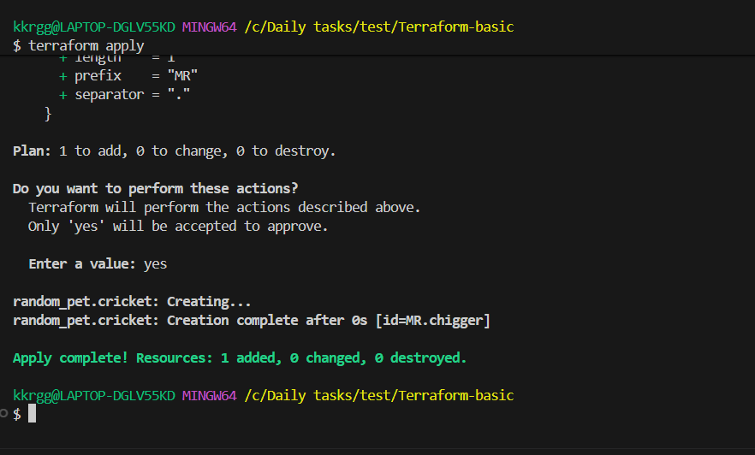
Checking terraform state list
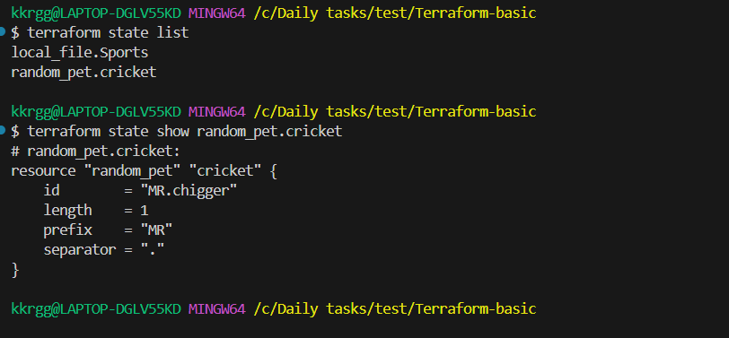
Terraform destroy
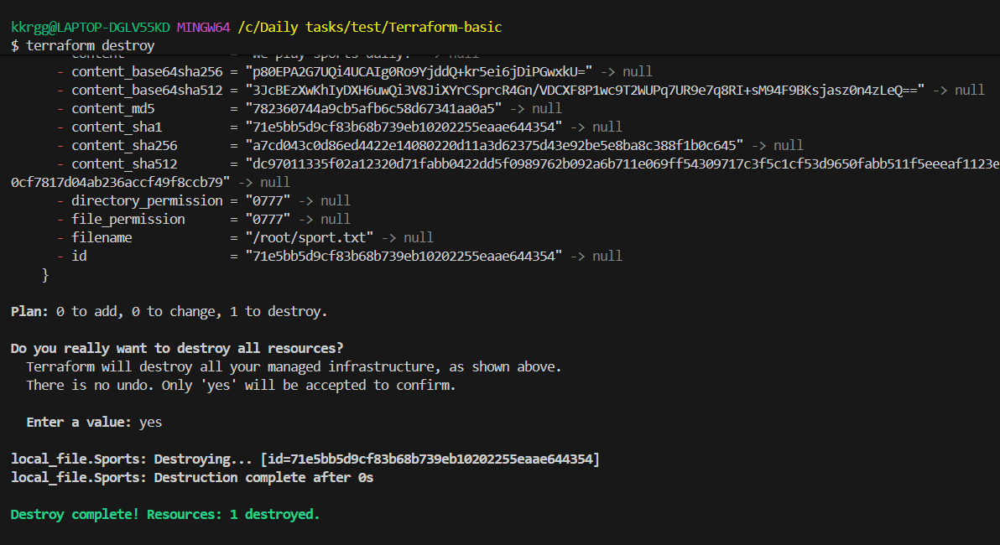

3). Note down below points, Terraform Init Terraform Plan Terraform Apply Terraform Provider.

1. terraform init
Initializes your Terraform project.
terraform init
Purpose:
- Downloads required providers
- Initializes the working directory
- Creates/updates .terraform directory
- Prepares Terraform to work with your configuration
Example:
main.tf
↓
terraform init
↓
Providers downloaded
↓
Ready for plan/apply
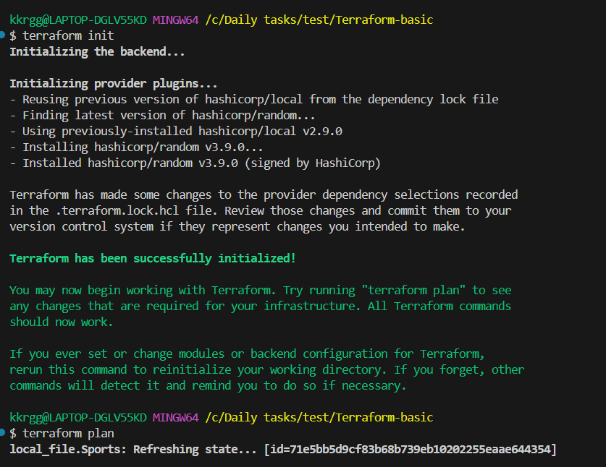

2. terraform plan
Shows what Terraform is going to do without actually creating or changing resources.
terraform plan
For your example, you might see:
Plan: 1 to add, 0 to change, 0 to destroy.
Think:
"Terraform, tell me what you are going to do."
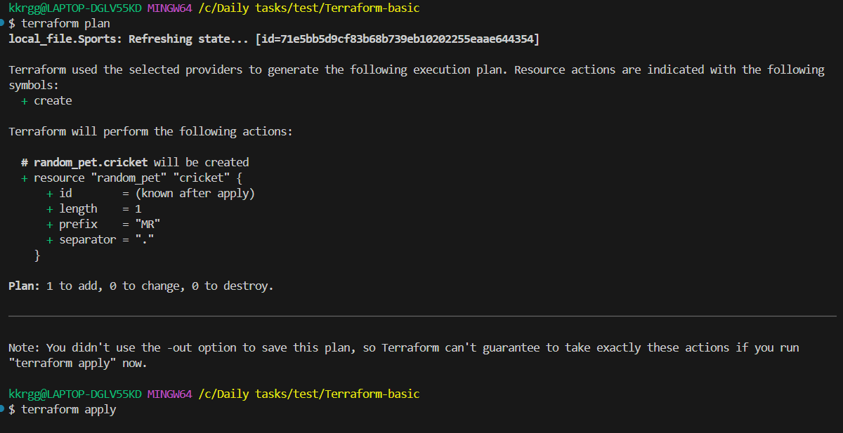

3. terraform apply
Actually creates or modifies the resources.
terraform apply
Terraform first shows the plan and asks:
Do you want to perform these actions?
Only 'yes' will be accepted to approve.

Enter a value: yes
Enter:
yes
Then Terraform creates the resources.
Think:
"Terraform, do it."
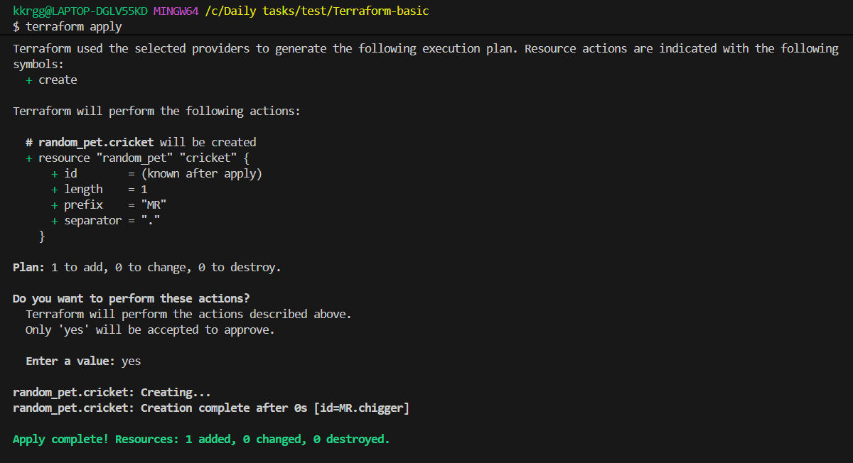

4. terraform show
Shows the current state of the resources managed by Terraform.
terraform show
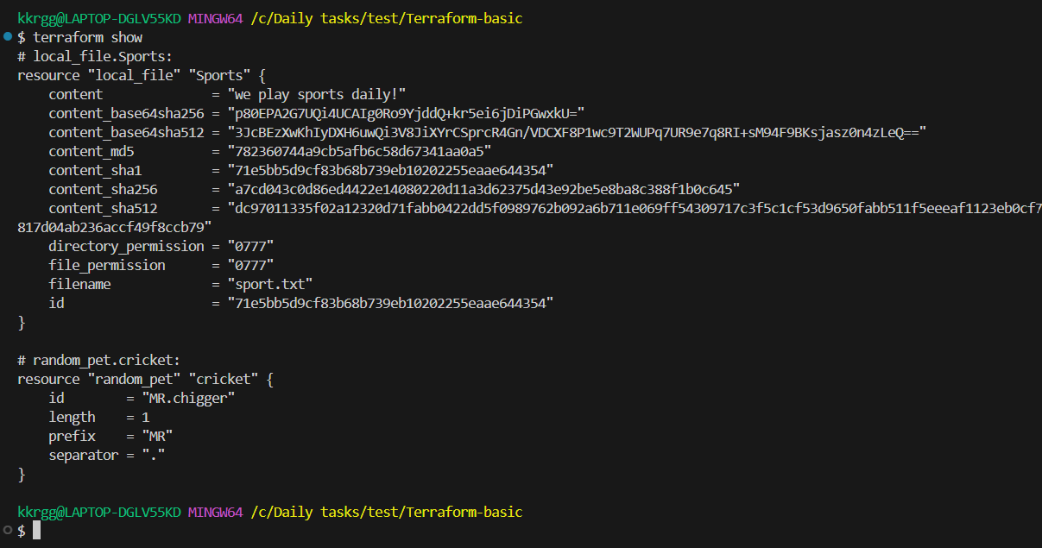
For your random_pet example, you could see:
random_pet.cricket:
id = "MR.chigger"
length = 1
prefix = "MR"
separator = "."
It is useful for checking what Terraform currently knows about your infrastructure.
You can also use:
terraform show terraform.tfstate

5. terraform destroy
Deletes the resources managed by Terraform.
terraform destroy
Terraform shows what it will delete and asks for confirmation:
Do you want to perform these actions?

Enter a value: yes
After confirmation:
Destroy complete! Resources: 2 destroyed.
For your example, it would remove:
local_file.Sports
random_pet.cricket
So sport.txt would be deleted as well.
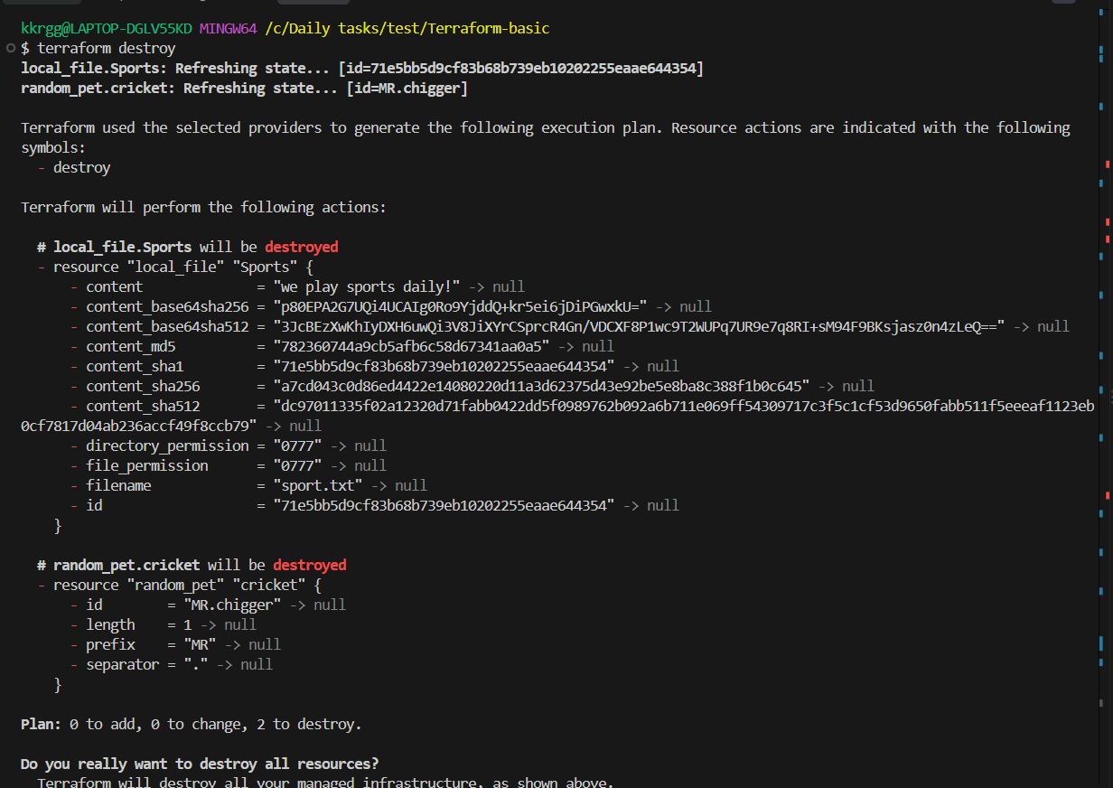
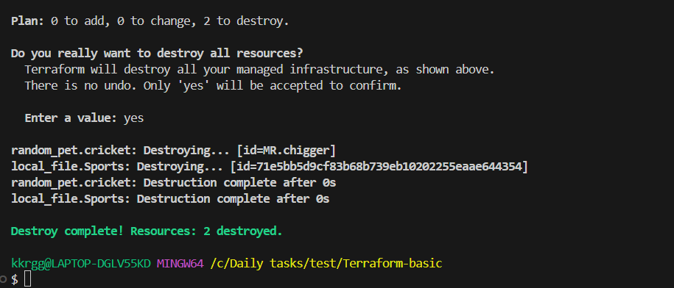

4). Integrate a sample Terraform template in Jenkins.
Objective:
Create a simple Terraform configuration and execute Terraform commands from a Jenkins pipeline.

1. Create a Terraform project
On your Jenkins machine, create a directory:
mkdir -p ~/terraform-jenkins
cd ~/terraform-jenkins
Create main.tf:
terraform {
required_providers {
local = {
source = "hashicorp/local"
version = "~> 2.5"
}
}
}

provider "local" {}

resource "local_file" "jenkins_demo" {
filename = "jenkins-demo.txt"
content = "Terraform executed successfully from Jenkins!"
}
This Terraform code will create:
jenkins-demo.txt
with:
Terraform executed successfully from Jenkins!
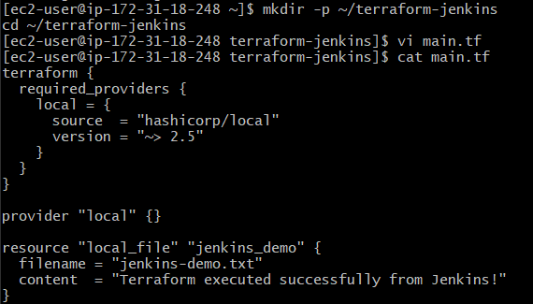

2. Test Terraform manually first
Inside the directory:
terraform init
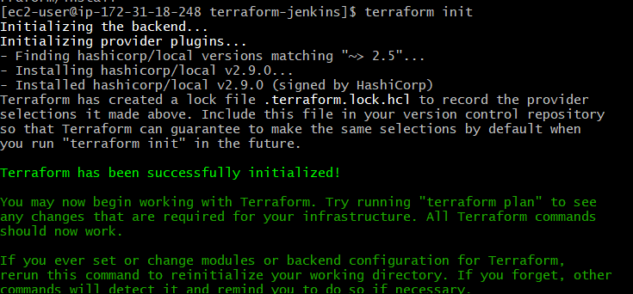
Then:
terraform plan
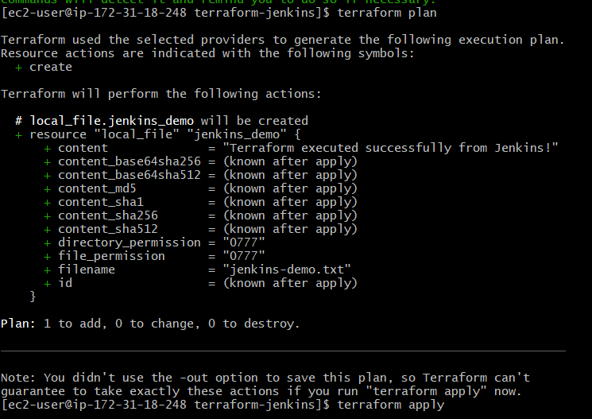
Then:
terraform apply -auto-approve
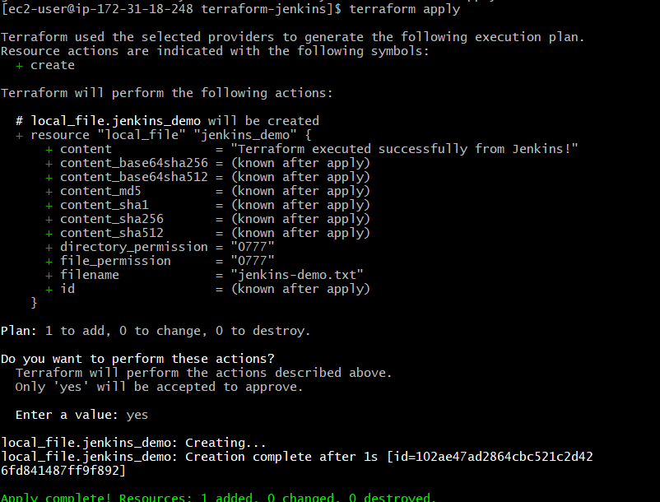
Check:
cat jenkins-demo.txt
You should get:
Terraform executed successfully from Jenkins!
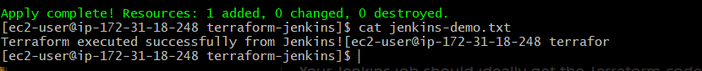
Now destroy it:
terraform destroy -auto-approve
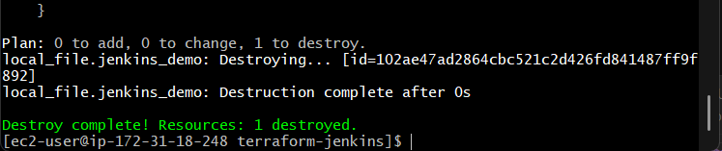

3. Put the Terraform code in GitHub
Your Jenkins job should ideally get the Terraform code from GitHub.
Your repository could look like:
terraform-jenkins/
├── main.tf
└── Jenkinsfile
Push both files to GitHub.
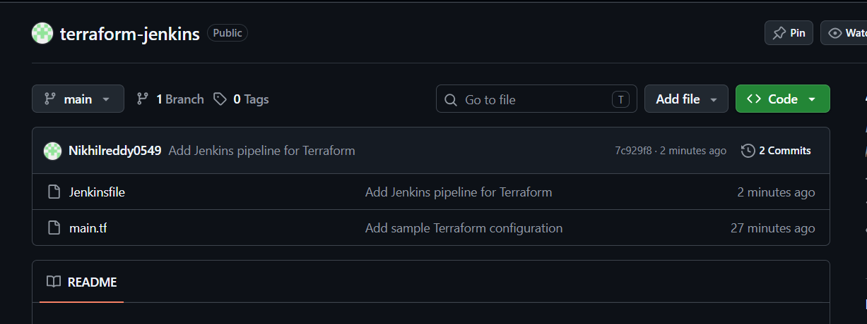

4. Create Jenkins Pipeline
In Jenkins:
Dashboard → New Item
Choose:
Pipeline
Give it a name such as:
Terraform-Jenkins-Demo
Select:
Pipeline
Then under Pipeline → Definition, you can initially select:
Pipeline script
and use:
pipeline {
agent any

stages {

stage('Checkout') {
steps {
git branch: 'main',
url: 'YOUR_GITHUB_REPOSITORY_URL'
}
}

stage('Terraform Init') {
steps {
sh 'terraform init'
}
}

stage('Terraform Validate') {
steps {
sh 'terraform validate'
}
}

stage('Terraform Plan') {
steps {
sh 'terraform plan'
}
}

stage('Terraform Apply') {
steps {
sh 'terraform apply -auto-approve'
}
}
}
}
Replace:
YOUR_GITHUB_REPOSITORY_URL
with your actual repository URL.

5. Run the Jenkins job
Click:
Build Now
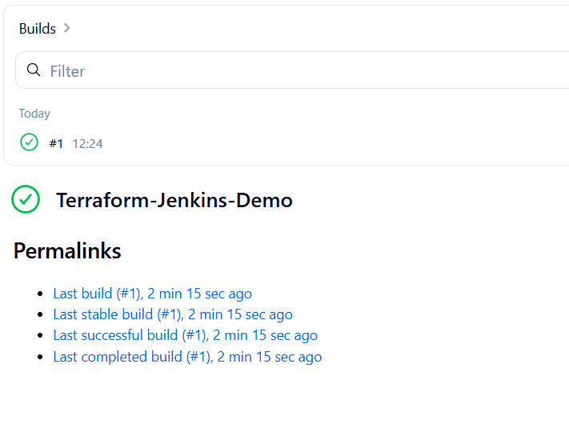
Jenkins will execute:
Checkout
↓
terraform init
↓
terraform validate
↓
terraform plan
↓
terraform apply
You should see in the Jenkins console:
Terraform has been successfully initialized!

Success! The configuration is valid.

Plan: 1 to add, 0 to change, 0 to destroy.

Apply complete! Resources: 1 added, 0 changed, 0 destroyed.
